**ESTIMATING TIME AND SETTING A SCHEDULE.**

* Explain why it’s necessary to create and manage a project plan.
* Discuss the definition of a project plan, and we’ll learn what typically foes into one.
* Share how to use time estimation methods to prevent failure.
* Examine tools and best practices you can use to build a project plan.

**Project Plan:**

* Tasks
* Milestones
* People
* Documentation (RACI, Charter, Budget, risk etc)
* Time

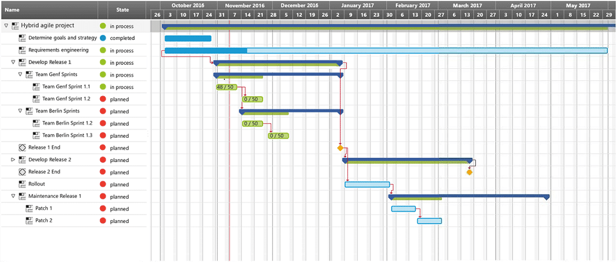

**Estimating time:**

**Time estimation:**

A prediction of the total amount of time required to complete a task.

Both starting and ending, active.

**Effort estimation:**

A prediction of the amount and difficulty of active work required to complete a task.

Unrealistic effort estimation happens when you’ve underestimated the amount of time it’ll take to complete a task.

This happens when you have too much optimism can lead to you overlooking potential risks that cloud set your plans behind schedule.

To avoid this, you can communicate with teammates assigned to each task as they will have the most realistic understanding of the amount of work required to complete a task, and can provide you with the best estimate.

Take into consideration sub-tasks required to complete the assigned task.

This could be researching, calling, and gathering to complete a task.

**Sub-tasks**:

Smaller tasks that are required to complete a larger task.

Good have a buffer for tasks, as to ensure if they done go to plan, you have time. To correct it.

**Buffer:**

Extra time added to the end of a task or project to account for unexpected slowdowns or delays in work progress.

**Types of scheduling buffers:**

* Task buffers
* Project buffers

**Task buffers:**

Extra time tracked onto a specific task.

They should be used primary for tasks that are out of the projects team’s control.

For example:

Asking a vendor for an estimate by Monday but you only need it grunted by Thursday, things are out of your control, give them shorter time than what you need to get a result.

Task buffers should be used more sparingly for tasks within the projects control like for tasks that are difficult or unpredictable.

**Project buffers:**

Extra time tacked onto the end of the project.

Like adding extra time to the supposed end date which will guarantee that you will have finished an have some extra time to finish things off.

* Use both time estimation and effort estimation to form the estimation of time required to complete a task.
* If there **is idle time** baked into a task during that time, you can get them to do something else.

**Capacity planning:**

**Capacity:**

The amount of work that the people. or resources assigned to the project can reasonably complete in a set period.

One should take into consideration a person’s capacity when assigned a task.

**Capacity planning:**

Refers to the act of allocating people and resources to project tasks and determining whether you have the necessary resources required to complete the work on time.

From this, you gin an undertaking to the task and a person capacity and what is needed.

From here you can either allocate people, gain new talent, or extend the time.

**Things affect capacity & planning:**

* Identify which tasks can happen in parallel vs which tasks can happen sequentially.

* Determine which projects tasks have a fixed start date.
* Determine which project tasks have an earliest start date.
* Identifying if a task has float (Amount wait before impacts schedule)
* Tasks on the critical path should have zero float.

For example:

If you need to deliver a lot of goods, and you determine the capacity from the drivers, first their albitites and feedback you can determine of the task if not fully cable by a single person so you can justify either getting more drivers, hiring more drivers, or one of these sorts pertaining to the 3 constraints, scope, budget, time.

**Critical path:**

The list of project milestones you must reach to meet the project goal on schedule, as well as mandatory tasks that contribute to the completion of each milestone.

So you must make a critical path that person follows which is what is needed to progress forward at the bare minimum.

The crucial path must be followed for each milestone, anything not in scope or urgent must be put aside.

For example:

Making a website or delivering the goods.

And not critical stuff like adding decorations would not be considered.

The first priorities are the tasks that are crucial to the project.

These are then the critical path you follow.

Your critical path includes the bare minimum number of tasks and milestones you need to reach your project goal.

**To determine the critical path of a project:**

* List all the tasks required to complete the project and milestones set out.
* Good time to refer to the WBS you made before.
* Then you determine the tasks that absolutely must be done to progress int the task hierarchy, which tasks are dependent on the last
* Work with the team, to make time estimates for each task and map each task from start to finish, the longest path is your critical path.